Movie: Notting Hill.
Scene: ‘The last brownie’ (At dinner, each guest attempts to win the last brownie by telling a moving story about his/her life).
Characters:
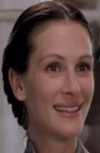
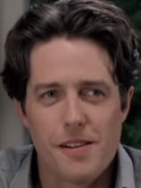William Anna Bernie
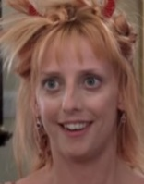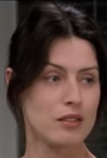

Honey Max Bella

Comprehension activity:
1. Write the name of the character who…
- gave up her favourite habit and can’t get pregnant. _______________
- doesn’t understand her/his job. _______________
- doesn’t have hair but ‘feathers’. _______________
- is unsuccessful professionally and divorced. _______________
- is afraid one day she/he’ll be forgotten by the audience. _______________
- used to have a funny nickname. _______________
- has not been dating anyone since she/he was a teenager. _____________
- was hit by one of his boyfriends. _______________
2. In your opinion, who deserves the last brownie? Why?

