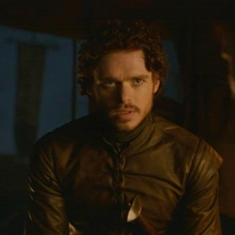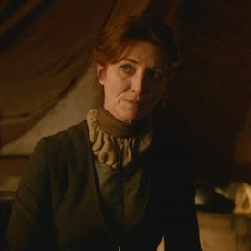
Robb Stark Catelyn Stark

Fill in the gaps
a) Walder Frey is a dangerous man to _____.
b) I know that seems_________ to you.
c) We built it______, over the years. _____ by _____.
d) It’s not as ________ as secret _______ in the woods.
e) And that’s what would be in _____ for me with one of Walder Frey’s daughters?
True or False
Catelyn’s husband loved her when they married
Catelyn thinks that secret passion lasts longer
Robb agreed to marry one of Walder Frey’s daughters
Robb’s father is alive

