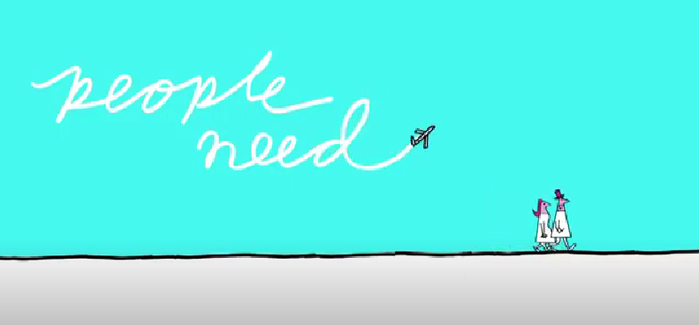
What do people need?

- Stanza 1
  - Read and practise shadow reading
  - Spot and explain allophonic variations
piːpl niːd piːpl |
tə wɔːk tu |
tə tɔ:k tu |
tə kraɪ ən rilaɪ ɒn |
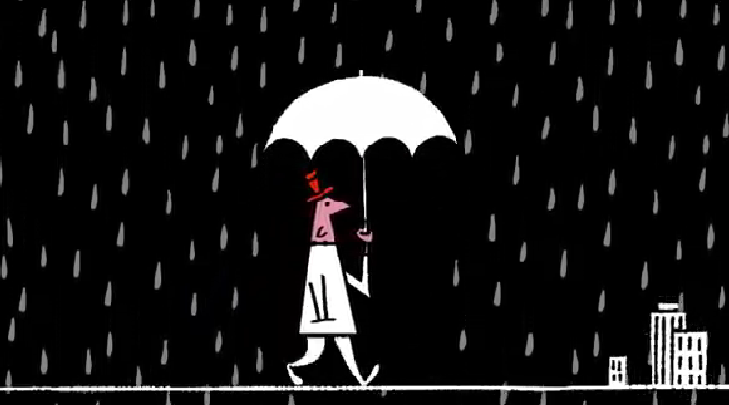
piːpl wɪl ɔːlweɪz niːd piːpl |
tə lʌv ən tə mɪs |
tə hʌɡ ən tə kɪs |
ɪts juːsfəl tə hæv ʌðə piːpl |
tə huːm wɪl ju məʊn |
ɪf jɔr ɔ:l ələʊn |
ɪts səʊ hɑ:d tə ʃeə |
wen nəʊ wʌn ɪz ðeə |
ðəz nɒt mʌtʃ tə du: |
wen ðəz nəʊ wʌn bət ju |
piːpl wɪl ɔːlweɪz niːd piːpl |

- Stanza 2
  - Transcribe and check
  - Record yourself. Swap audios with a partner and analyze it, focusing on the production of connected speech features. Don´t disregard stress and the vocalic system.
To please
To tease
To put you at ease,
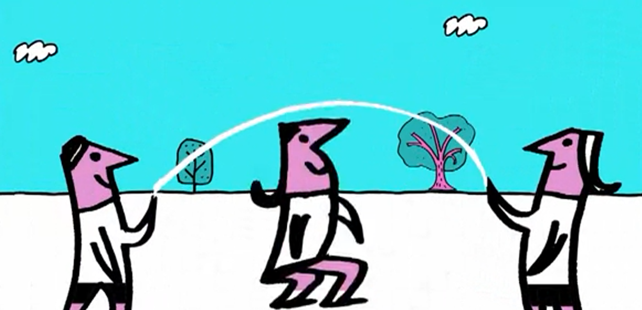
People will always need people.
To make life appealing
And give life some meaning,
It’s useful to have other people.
If you need a change
To whom will you turn.
If you need a lesson
From whom will you learn.
If you need to play
You’ll know why I say
People will always need people.

- Stanza 3 - Dictation

