Listening Practice #1

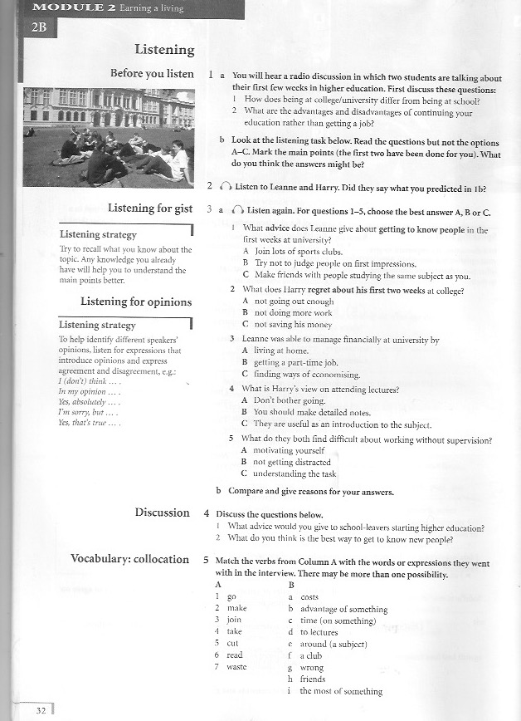
First few weeks in higher education

