lesson 5 - Clusters / Vowels and Diphthongs – Allophonic variations

discuss the MEME in the light of levelling and monophthongization

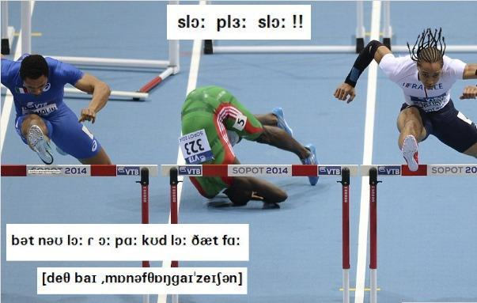

More examples on levelling / monophthongization: listen and mark which form you hear.

FIRE / faɪə / /faə / /fɑː/
Video 1
Video 2
Video 3
TOWER /ˈtaʊə / /ˈtaə / /ˈtɑː/
Video 1
Video 2
Video 3

genially
https://view.genial.ly/61577f4cdb77860dd30e026d/interactive-content-allophonic-variants-clusters-vowels

