LESSON 2
IPA - Silent Letters – Difficult sounds:/b/ v/

https://view.genial.ly/605b76c1f4f3880ceee9fda6/presentation-genially-sin-titulo

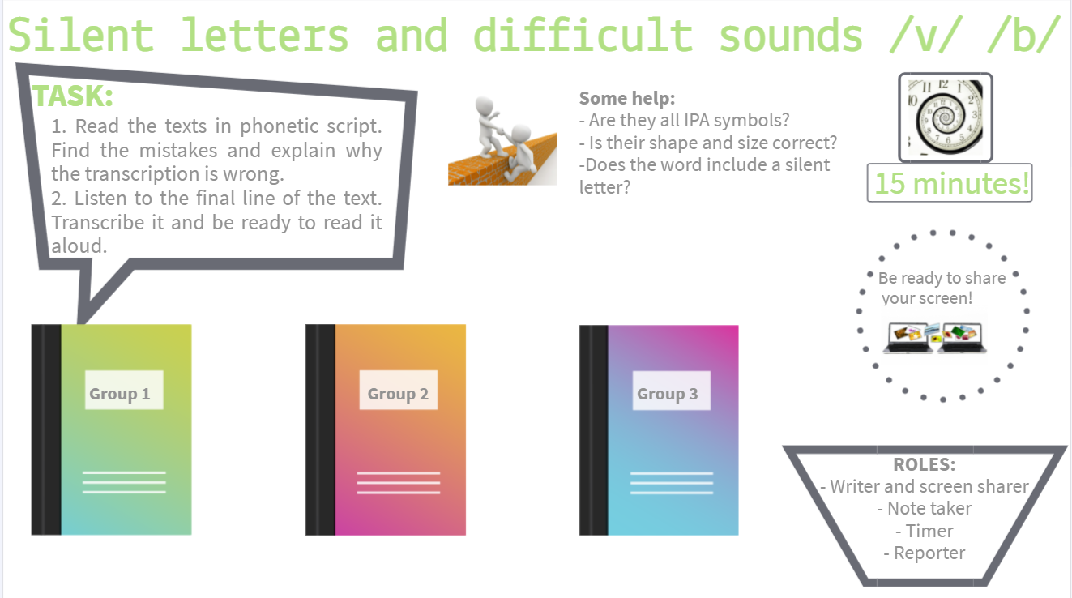

1 - In 3 or 6 BR, each group of SS are given one text in phonetic script and an audio file. Sts spot the mistakes in the text, and get ready to account for them. All the mistakes involve IPA format and silent letters.
2 – They copy down in transcription the short audio which closes the text.
3 – Back in main session, each group “presents” to the class the mistakes they spotted and explain.
4 – Sts read aloud the line that they copied from the audio. T monitors production of /b/ /v/
TEXTO 1
Robert: We should talk about it, seriously.
Me: I don´t know, I´m not sure.
Robert: Let´s face it, it´s high time you listened to me!
Me: I really doubt it.
Robert: Don´t be a coward! At least do it for your honour!
Me in my head: (audio) Robert´s big words just vanished. Robert´s very bossy!!

TEXT1 WITH ERRORS
| ˈRɒbət | wi S ˈtɔːlk əˌbaʊt ˈɪt |ˈsɪərɪəsli |
miː |ˈaɪ dəʊnt ˈknəʊ |aɪm nɒt ʃʊə |
ˈrɒbət |lets feɪs ˈɪt |ˈɪts ˌhaɪg ˈtaɪm yu d t mi |
miː |ˈaɪ ˈrɪəli daʊbt ˈth |
ˈrɒbət |dəʊnt bi ə ˈcaʊəd |ət liːst du: ˈɪt fə  ˈhɒnə |

KEY TEXT 1
| ˈrɒbət | wi ʃəd ˈtɔːk əˌbaʊt ˈɪt |ˈsɪərɪəsli |
miː |ˈaɪ dəʊnt ˈnəʊ |aɪm nɒt ʃʊə |
ˈrɒbət |lets feɪs ˈɪt |ˈɪts ˌhaɪ ˈtaɪm ju ˈlɪsn̩d t mi |
miː |ˈaɪ ˈrɪəli daʊt ˈ |
ˈrɒbət |dəʊnt bi ə ˈkaʊəd |ət liːst du: ˈɪt fə  ˈɒnə |

TEXTO 2
Imagine a foreign island… the sea…. The beach… the sandcastles…. peacefully, you are combing your hair…. Which is a sign that you are happy.
Half an hour more, and you are happier.
Suddenly you see a whistle, it´s silver, it´s in your hands…
(audio) prrrrrrrrrr! Wake up! Big valuable day! Best day ever! Happy Birthday!

TEXT2 WITH ERRORS
| ɪˈmædʒɪn ə ˈfɒrəgn ˈaɪslənd … ðə ˈsi: … | ðə ˈbi:ch … ðə ˈsændkɑːstl̩z |
ˈpiːsfəli | ju ə ˈkəʊmbɪŋ jə heə … | wɪtʃ ɪz ə ˈsaɪgn  ju ə ˈhæppi |
hɑːlf ən ˈaʊə mɔː | ənd ju ə ˈhæpiə |
Sʌdn̩li ju ˈsi: ə ˈwhɪstl̩ | ˈɪts ˈsɪlvə | ˈɪts ɪn j hændz … |

KEY TEXT 2
| ɪˈmædʒɪn ə ˈfɒrən ˈaɪlənd … ðə ˈsi: … | ðə ˈbi:tʃ … ðə ˈsændkɑːsl̩z … |
ˈpiːsfəli | ju ə ˈkəʊmɪŋ jə heə … | wɪtʃ ɪz ə ˈsaɪn  ju ə ˈhæpi |
hɑːf ən ˈaʊə mɔː | ənd ju ə ˈhæpiə |
sʌdn̩li ju ˈsi: ə ˈwɪsl̩ | ˈɪts ˈsɪlvə | ˈɪts ɪn j hændz … |

TEXTO 3
Me: Let me buy you a treat … I´m in debt with you…
Bobby: Don´t worry, no need…
Me: Honestly, don´t get me wrong, you saved my whole world!
Bobby: Okay, I would like a salmon sandwich and a bottle of champagne, and some chocolates, please.
Me in my head: (audio) I believe inviting Bobby shouldn´t be so excessive!

TEXT3 WITH ERRORS
| miː | ˈlet mi baɪ ju ə triːt | aɪm ɪn debt wɪth ju … |
ˈBɒbi | dəʊnt ˈwʌrri | ˈnəʊ niːd … |
miː |ˈhɒnɪstli | dəʊnt ˈget miː wrɒŋ | ju seɪvd maɪ ˈwhəʊl wɜːld |
ˈbɒbi |ˌəʊˈkeɪ |ˈaɪ wʊld laɪk ə ˌsælmən ˈsændwɪdʒ ənd ə bɒtl əv ʃæmˈpeɪn |ənd səm ˈchɒkləts | pliːz |

KEY TEXT 3
| miː | ˈlet mi baɪ ju ə triːt | aɪm ɪn det wɪð ju … |
ˈbɒbi | dəʊnt ˈwʌri | ˈnəʊ niːd … |
miː |ˈɒnɪstli | dəʊnt ˈget miː rɒŋ | ju seɪvd maɪ ˈhəʊl wɜːld |
ˈbɒbi |ˌəʊˈkeɪ |ˈaɪ wʊd laɪk ə ˌsæmən ˈsænwɪdʒ ənd ə bɒtl əv ʃæmˈpeɪn |ənd səm ˈtʃɒkləts | pliːz |

