RECAP TP3
Retomar randomly dialogos de todo TP3
Practice of difficult pairs

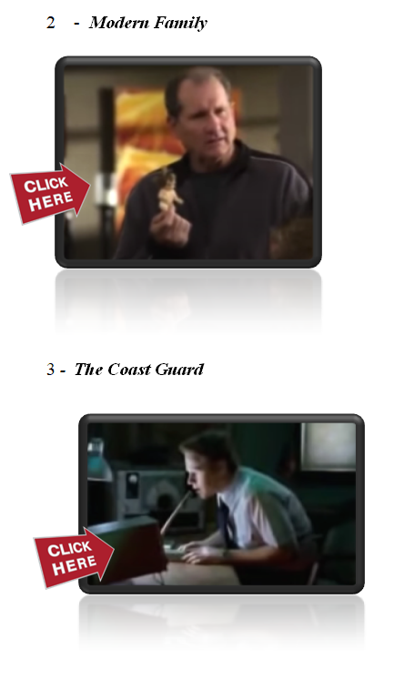
Discuss the jokes in the TP:

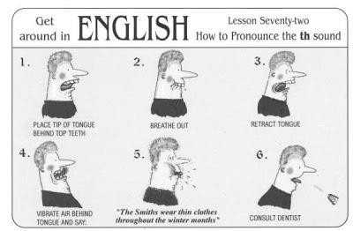
1 -

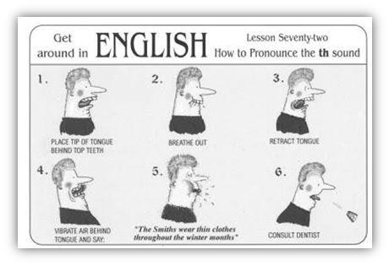

Exemplify next task using the following map:
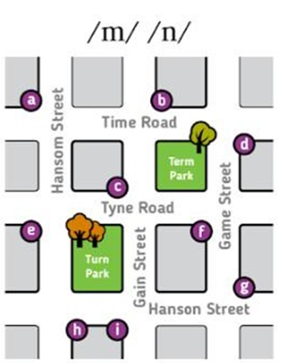
You will now work in groups. You will be assigned a map like this one below. In each map, the places marked a – i are cafes. One of you will indicate the address of a café like this:
‘It’s on the corner of Time Road and Gain Street (opposite Term Park)
The other students in the group may request clarification:
‘Sorry, did you say Tyne Road?’
‘Sorry, did you say Game Street?’
The students in the group have to find which café the speaker is talking about.
It’s b.
All the students in the group have to ask about one café.

https://view.genial.ly/606113cc410dd80d483b6369/presentation-difficult-pairs
