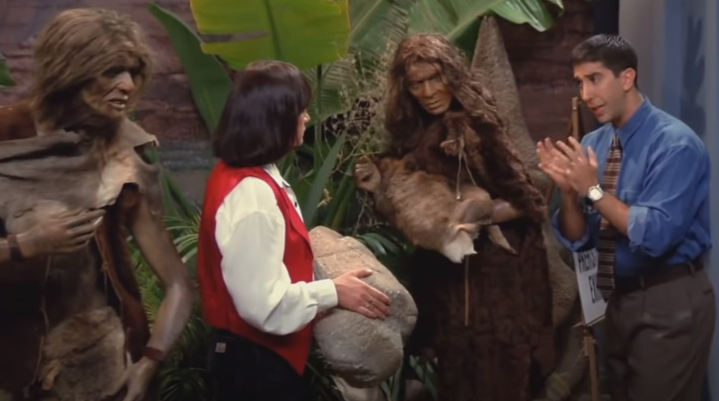


Read the dialogue between Ross and Marsha in an episode from and think:

- Why does Marsha think the cave woman should look angry?
- Why doesn’t Ross agree?

https://www.youtube.com/watch?v=-zPvgFT0nnQ

Sort out the words according to the highlighted vowel sound:

KIT | FLEECE | DRESS | TRAP | STRUT | SCHWA

ROSS: No, it's good, it is good, it's just that- mm- doesn't she seem a little angry?

MARSHA: Well, she has issues.

ROSS: Does she.

MARSHA: He's out banging other women over the head with a club, while she sits at home trying to get the mastodon smell out of the carpet!

ROSS: Marsha, these are cave people. Okay? They have issues like 'Gee, that glacier's getting kinda close.' See?

MARSHA: Speaking of issues, isn't that your ex-wife? (CAROL HAS ENTERED BEHIND THEM, OUTSIDE THE EXHIBIT)

ROSS: (TRYING TO IGNORE HER) No. No.

MARSHA: Yes, it is. Carol! Hi!

ROSS: Okay, okay, yes, it is. (WAVING) How about I'll, uh, catch up with you in the Ice Age.

https://view.genial.ly/60c01fe6c455270d104dbe74/interactive-content-genially-sin-titulo

