
Fonética y Fonología Inglesa 1 – Cursada 2025
IMPORTANT INFORMATION

Every week you are asked to complete an assignment in campus.
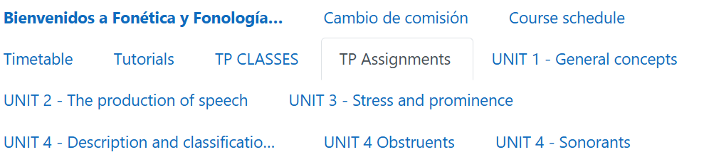

This is how you should work:
1. Complete the assignment on campus. Upload the exercises that require a picture of your work. Once you finish the assignment, you will be shown the correct answers.
2. Go back to the work you did in paper (the exercises that require a picture of your work) and CORRECT your mistakes using a different colour pen.
3. Write down your name and the group you belong to, the assignment you have done, and the number of the exercise that you are handing in.
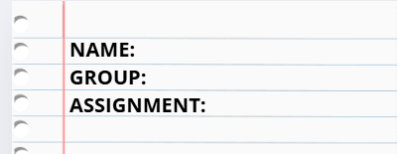
4. Bring the corrected exercises and hand them in to your teacher in the CLASES PRACTICAS Exercises that have NOT been checked or have been POORLY checked will not be accepted. Pay attention to the dates when you need to hand in (the week AFTER you are supposed to have completed the assignment). Exercises that do not correspond to the set date won’t be accepted.
If there are no classes for your group during a certain week (holiday, strike, etc.) please bring your work the following week.

Remember you need 75% of your work done and handed in.
Assignment | Exercises to hand in | Date TO HAND IN (you should complete the assignment the previous week)
1 | Ex 6, 7 and 8 | 7-12/4
2 | Ex 5, 6 and 8 | 14-16/4
3 | Ex 4, 7, 11 and 12 | 28/4-2/5
4 | Ex 3 and 4 | 12-16/5
5 | Ex 3 and 4 | 19-23/5
6 | Ex 1 (Transcription and dictation) | 2-6/6
7 | Ex 3 and 4 | 9-13/6
8 | Ex 2 (Transcription and dictation) | 17-19/6
9 | Ex 1 (Transcription and dictation) | 11-15/8
10 | Ex 1 (Transcription and dictation) | 18-22/8
11 | Ex 2 (Transcription and dictation) | 25-29/8
12 | Ex 2 (Transcription and dictation) | 1-5/9
13 | Ex 2 (Transcription and dictation) | 8-12/9
14 | Ex 2 (Transcription and dictation) | 15-19/9
15 | Ex 2 (Transcription and dictation) | 22-26/9
16 | Ex 2 (Transcription and dictation) | 6-10/10
17 | Ex 2 (Transcription and dictation) | 13-17/10

