
Further examples:

- A WOMAN WITHOUT HER MAN IS NOTHING
A WOMAN WITHOUT HER MAN IS NOTHING
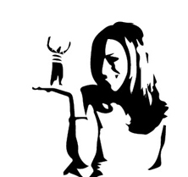

- I WANT TO THANK MY PARENTS TIFFANY AND GOD
I WANT TO THANK MY PARENTS TIFFANY AND GOD

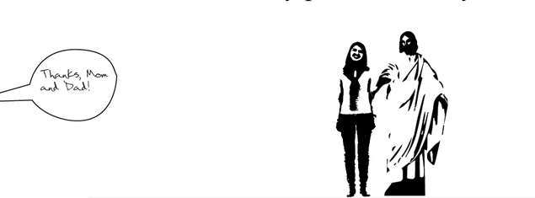

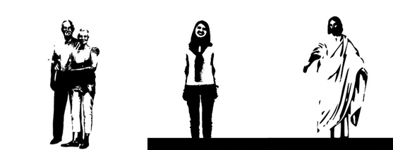

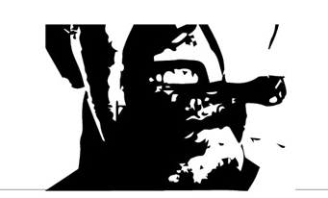
- IT’S A MAN EATING CHICKEN
IT’S A MAN EATING CHICKEN

