V) Role-Play. Six years later Peter and Amanda bump into each other again. Read the information
in your card. Roleplay their dialogue.

Amanda

- still lives in London
- is single and has rescued two dogs, which keep her company
- realised she has always been in love with Peter.

Ask Peter:
- still happy with your job as a lawyer?
- married? children?
- still have feelings for her?

Peter

- realised he does not really enjoy being a lawyer, started drama lessons, perfoms in small theatre companies.
- had never imagined but is now married and has 2 children
- has got over Amanda

Ask Amanda
- still live in London?
- married? children?
- boyfriend?

PRACTICE A – PAIR WORK
Part 1
Imagine you’re a bridesmaid or best man at your foreign friend’s wedding and you have to give a speech. Prepare a short speech about how you met your friend; include a short anecdote you went through together.
Make notes for your speech and then record yourself giving the speech. Exchange recordings with your partner.

Part 2
As you listen to your partner’s recording, asses pronunciation and intonation choices. Make notes of any comments you would like to mention later.

PRACTICE B
Part 1
Student A
The following passage explains the process of photosynthesis. Read the passage to your partner.
Student B
What kind of reading has your partner assumed?

Then exchange roles.

The process of photosynthesis
- Photosynthesis is a chemical reaction that takes place inside a plant, producing food for the plant to survive.
- Carbon dioxide, water and light are all needed for photosynthesis to take place.
- Photosynthesis happens in the leaves of a plant.
Plants need food to respire, grow and reproduce. Unlike animals, plants are able to make their own food by the process of photosynthesis. Photosynthesis takes place in the part of the plant cell containing chloroplasts, these are small structures that contain chlorophyll. For photosynthesis to take place, plants need to take in carbon dioxide (from the air), water (from the ground) and light (usually from the sun).
Here is the word equation for photosynthesis:
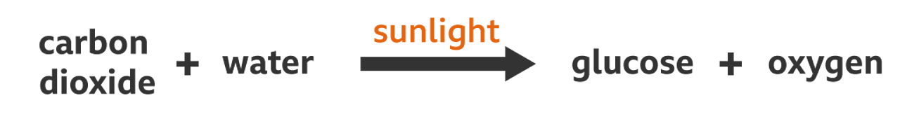

Part 2
Read the information above about photosynthesis and imagine you had to explain the process to students, using these posters as an aid. Exchange roles with your partner.
