FF2 –2do parcial escrito 2025
- READ the passage
- Transcribe the passage. Transcribe the names of the speakers only ONCE. DO NOT transcribe stage directions
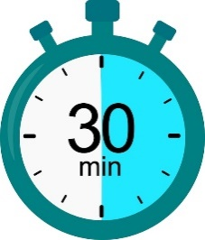
- LEAVE A LINE IN BETWEEN
- LISTEN to the recording
Remember you have 30’ to finish the test
GERALD: I'd like to have a look at that photograph now, Inspector.
INSPECTOR: All in good time.
GERALD: I don't see why –
INSPECTOR: You heard what I said before, Mr Croft. One line of inquiry at a time. Otherwise, we'll
all be talking at once and won't know where we are. If you've anything tell me, you'll have an opportunity of doing it soon.
GERALD: Well, I don't suppose I have –
ERIC: Look here, I've had enough of this.
INSPECTOR: I dare say.
ERIC: I'm sorry – but you see – we were having a little party – and I've had a few drinks, including rather a lot of champagne – and I've got a headache – and as I'm only in the way here, I think I'd better turn in.
INSPECTOR: And I think you'd better stay here.
ERIC: Why should I?
INSPECTOR: It might be less trouble. If you turn in, you might have to turn out again soon.
GERALD: Getting a bit heavy-handed, aren't you, Inspector?

