- The following text is about a unique educational institution in Berlin with a radically different teaching approach. Read the article and describe this school system briefly?

No grades, no timetable: Berlin school turns teaching upside down

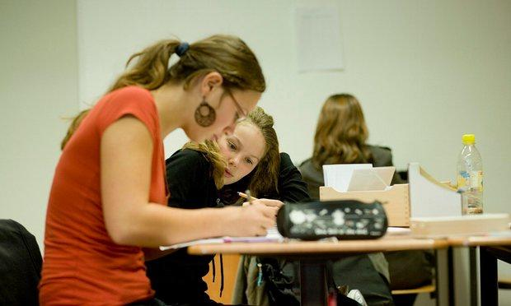
Philip Oltermann, 1 July, 2016

Anton Oberländer is a persuasive speaker. In 2015, when he and a group of friends were short of cash for a camping trip to Cornwall, he convinced Germany’s national rail company to give them some free tickets. Anton is 14 years old.
The Berlin teenager has a lot of self-confidence. He gets this from his school – a school that
has turned traditional teaching upside down. At Oberländer’s school, there are no grades until students are 15 years old, no timetables and no lecture-style lessons. The pupils decide which subjects they want to study for each lesson and when they want to take an exam.
Set subjects are maths, German, English and social studies. Students also study other courses such as “responsibility” and “challenge”. For challenge, students aged 12 to 14 are given €150 and go on an adventure that they have to plan entirely by themselves. Some go kayaking; others work on a farm. Anton went trekking along England’s south coast.
4Job requirements are changing and smartphones and the internet are changing how young people read and understand information. For these reasons, the school’s headteacher, Margret Rasfeld, says that the most important skill a school can give its students is the ability to motivate themselves.
“Look at three- or four-year-olds – they are all full of self-confidence,” Rasfeld says. “Often, children can’t wait to start school. But, sadly, most schools take away that confidence.”
The Evangelical School Berlin Centre (ESBC)is trying to “reinvent what a school is”, she says. “Schools should prepare young people for change, or, better still, make them look forward to change. In the twenty-first century, schools should see it as their job to develop strong personalities.”
Making students listen to a teacher for 45 minutes and punishing them for working together on an exercise, Rasfeld says, does not produce the result schools want. “Nothing motivates students more than when they discover the meaning behind a subject by themselves.”
Students at her school are encouraged to find other ways to show what they have learnt, such as coding a computer game instead of sitting
a maths exam. Oberländer said he learnt more English on his trip to Cornwall than in several years of learning the language at school.
Rasfeld’s school has a strict system of rules. Students who don’t do all their work during lessons have to come into school on Saturday morning to study. “The more freedom you have, the more structure you need,” says Rasfeld.
The main reason why people are saying that ESBC is Germany’s most exciting school is that its students achieve impressive results. Year after year, pupils at Rasfeld’s school have the best grades of all Berlin’s comprehensive schools. 2015’s ESBC school leavers achieved an average grade of 2.0, the equivalent of all Bs.
The school opened in 2007 with just 16 students and now has 500 pupils and a long waiting list. A place at the school usually costs between €720 and €6,636 a year. About 5% of students do not have to pay any fees.
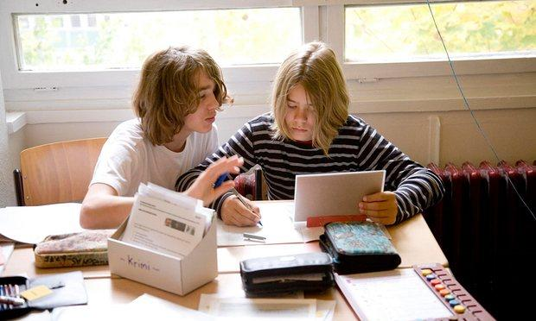
However, Rasfeld says that finding teachers able to adjust to the school’s methods can be harder than getting students to do the same.
Rasfeld has big plans. The school is developing teaching materials for other schools. About 40 schools in Germany are starting to use some or all of Rasfeld’s methods.
“Things are just starting,” says Rasfeld. “In education, you can only create change from the bottom.”
© Guardian News and Media 2016
First published in The Guardian, 01/07/16

Read the article again and Answer the questions with information from it.

- How many pupils does ESBC have and where is it?
- How much does it cost to send a child to the ESBC?
- What subjects must pupils learn at the school?
- If the students don’t want to take an exam, what can they do?
- What unusual challenge are 12- to 14-year-old pupils at ESBC given?
- What average grade have recent ESBC school leavers achieved?
- Is this better or worse than other schools in Berlin?
- What do ESBC students have to do if they don’t do all their school work on time?

- This article was shared on Facebook. Write your comment, use this question to guide you: Do you think that the ESBC school system would be successful in your country? Why? Why not?



…………………………………………………………………………
…………………………………………………………………………
…………………………………………………………………………

- Translate the text.

